ID 1029
All-Plant Fiber Composite as a Candidate for Fully Biodegradable Material

Ming Qiu Zhang, Min Zhi Rong, Xun Lu, Guang Shi, Gui Cheng Yang and Han Min Zeng

Materials Science Institute, Zhongshan University, Guangzhou 510275, China
Key Laboratory for Polymeric Composite and Functional Materials of Ministry of Education, Zhongshan University, Guangzhou 510275, China

SUMMARY: Plasticization of China fir sawdust was carried out in the present work to prepare natural resources based plastics. It was found that thermoplasticity and mechanical properties of the chemically modified wood flour changed with the substitution reaction conditions. By compounding sisal fibers and the plasticized fir sawdust, unidirectional laminates were manufactured similar to conventional thermoplastic composites. Such an all-plant fiber composite material is characterized by easy processing, environment friendly and low cost. Instead of chemical heterogeneity of conventional composites, physical heterogeneity of the current natural fiber composite is favorable for interfacial interaction. However, the reinforcing sisal fibers were not well impregnated with the matrix due to the relatively high viscosity of benzylated fir sawdust. Further efforts should be made in this area on the basis of the current preliminary work in order to improve mechanical properties of the composites.

KEYWORDS : All-Plant Fiber Composites, Sisal, Benzylation, Unidirectional Laminates

INTRODUCTION
Fiber reinforced polymer composites have been widely used in many fields mainly because of their high specific stiffness and strength. Recently, with increasing energy crisis and ecological problems, material scientists began to take interest in vegetable fiber serving as a substitute for man-made fiber in the composites [1, 2]. In fact, these composites are not environment friendly enough due to the fact that the matrix resins are synthesized products from earth oil and mostly non-biodegradable.

Considering the existing dilemma, the authors of the present work use modified plant fiber which can be processed like conventional polymers as matrix to make plant fiber reinforced plasticized plant fiber composite. The following benefits will be gained accordingly. (1) As natural fibers are slightly modified as a whole by chemical methods, cost effectiveness characterized by the renewable raw materials is maintained. (2) Fully biodegradable ability is associated with the composite because both the reinforcer and matrix are biomaterials. (3) Instead of chemical heterogeneity of conventional composites, physical heterogeneity of the all-plant fibers composite is favorable for interfacial interaction.

Plant fiber consists of cellulose, hemicellulose, lignin and a small amount of extractives. Cellulose is the essential component and belongs to an isotactic β-1, 4- polyacetal of cellulose. High degree of crystallinity of cellulose as well as three dimensional reticulate structure of lignin make plant fibers far from thermoplastic materials. However, the crystalline structure of cellulose might be disrupted by substituting its hydroxyl group with some chemical reagent [3, 4]. This decrystallization process helps to improve thermoplasticity of cellulose since the substitution groups act as plasticizer. Etherification, esterification and graft-copolymerization are proved to be effective to introduce plasticization into cellulose. Therefore, plant fibers can thus be converted into thermoplastics by using these techniques [5].

EXPERIMENTAL
China fir sawdust was ground into a mesh size of 80~100 and then dried under vacuum at 80ºC overnight. After being pre-swelled by 10N NaOH for 1 hour, the powder was transferred into a flask containing (CH₃)₄NI and benzyl chloride. The reaction was carried out under vigorous stirring at 120ºC for 4~10 hours to get benzylated products with various reaction extents. The products were purified through washing for 2-3 times with distilled water to remove inorganic salts, and with ethanol to remove residues of benzyl chloride and by-products, respectively. Finally the treated sawdust was dried again under vacuum at 80ºC overnight for being used as composite matrix.

As the modified fir exhibits rather high viscosity which can not be measured by a conventional melt indexer, a home-made tester (Fig.1) was used to assess its flowability in terms of melt index (MI, defined as the weight of the material flowing out of the nozzle in gram within 10 minutes under given pressure and temperature) and flow temperature (defined as the temperature at which the material begins to flow out of the nozzle during heating under a given pressure).
PLUNGER
MOULD
NOZZLE
(φ=1mm)
POWDER TO
BE TESTED
THERMOMETER
PRESSURE
HEATING
Fig.1 Sectional drawing of the home-made melt index tester

To produce plates of neat matrix and unidirectional sisal laminates, benzylated fir sawdust alone and its mixture with continuous sisal fiber at a desired proportion were compressed into sheets using a hot press at 130ºC under 10MPa. The molding conditions were chosen based on the viscosity measurements.

Chemical structure of the fir sawdust before and after the treatment was analyzed with a Bruker Equinox 55 Fourier Transform Infrared (FTIR) spectrometer. In addition, variations in the supramolecular structure were determined by a Rigaku D/Max-3A wide angle X-ray diffractometer (WAXD, CuK_{α} radiation, 35kV and 25mA). Tensile and three-point bending tests of the neat matrix and sisal laminates were carried out on a LWK-5 universal tester at crosshead speeds of 5mm/min and 1mm/min, respectively. Unnotched Charpy impact strength was measured by an XJJ-5 impact tester. The fractured surface was observed using a Hitachi S-520 scanning electron microscope (SEM).

RESULTS AND DISCUSSION
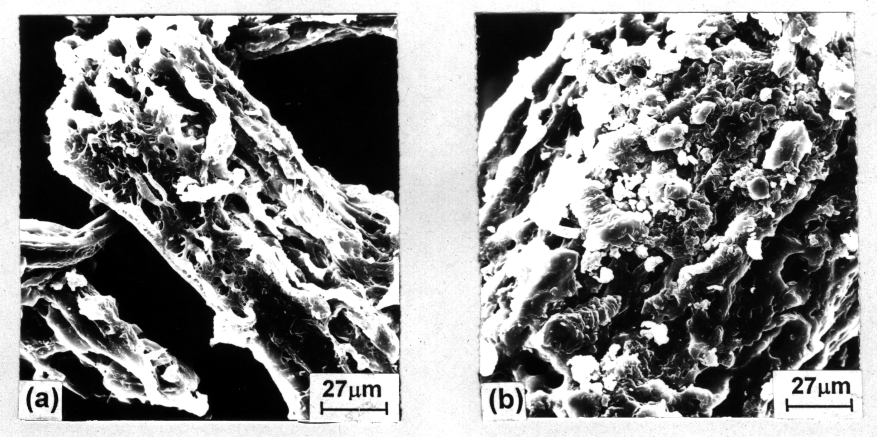
1. Characterization of benzylated fir sawdust
Fig. 2 SEM micrograph of (a) fir sawdust and (b) its benzylated version

Fig.2 illustrates the morphology of fir sawdust before and after benzylation treatment. The distinct variation lies in the fact that the modified one has an expanded appearance. Benzylation of wood is a typical Williamson synthesis reaction, which involves nucleophilic substitution of an alkoxide or a phenoxide ion for a halide ion [6]:
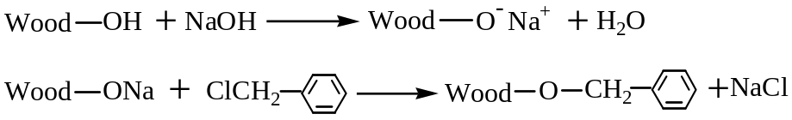where wood-OH represents hydroxyl in the wood polymeric components. Since cellulose constitutes the majority of wood and lignin contains little hydroxyl, benzyl chloride has to react mainly with the hydroxyl of cellulose. Hon et al reported that wood species have little effect on the rate of benzylation [6], but the reaction turned out to be quite slow in the case of fir powder when the conditions suggested in ref.[6] were followed. Our experimental results show that the reaction is remarkably influenced by the concentration and amount of NaOH, amount of benzyl chloride, reaction temperature and time. Based on these findings, the extent of benzylation of fir can be adjusted by taking appropriate measures. Fig.3 illustrates that the chemical structure of benzylated fir is quite different from that of the untreated version. Hydroxyl absorption at about 3400cm⁻¹ diminishes after benzylation as a result of etherification. Because the appearance of the bands at 1800-1950, 1600, 736 and 695cm⁻¹ is indicative of the mono-substituted benzene rings in benzyl groups, it can be concluded that the hydroxyl groups of cellulose have been substituted by benzyl groups. By comparing curves 2 and 3, it is seen that the characteristic peaks of benzyl group become stronger with a rise in the amount of the substituent.
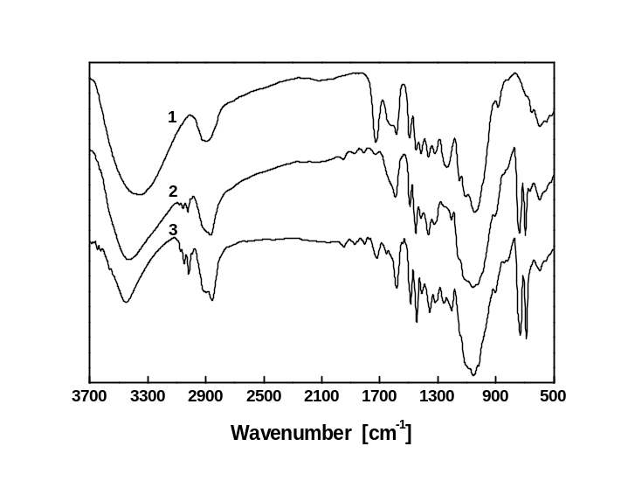
Fig.3 FTIR spectra of (1) unmodified fir sawdust and (2, 3) benzylated fir sawdust with different weight gains (curve 2: 47%, curve 3: 98%)

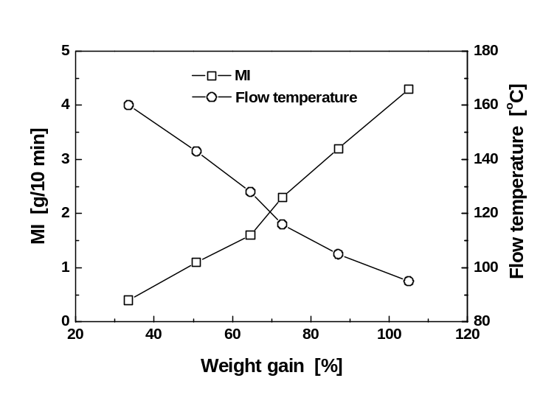
For an accurate analysis of the reaction and the resultant, degree of substitution originating from benzylation process should be known. Due to the chemical heterogeneity of wood, this parameter is factually hard to be measured. Instead, the extent of benzylation reaction can be evaluated by the percentage weight gain, which has explicit engineering meaning. As exhibited in Fig.4, an increase in the weight gain of the benzylated fir sawdust corresponds to an improvement of its thermal flowability. That is, the more hydroxyl groups of cellulose are substituted by benzyl groups, the higher the melt index and the lower flow temperature.
Fig.4 Effect of weight gain on flow temperature and MI of benzylated fir sawdust (pressure=6MPa)

The data in Fig.4, on one hand, demonstrate that the fir sawdust has been converted into a thermoplastic material after benzylation and acquired thermoforming ability. On the other hand, they reveal that the processing window of bezylated fir sawdust is a function of molding temperature and pressure. For designing purpose, the temperature sensitivity index, I(T)_{p}, defined as melt index ratio at a temperature difference of 30ºC for a given pressure, p, and the pressure sensitivity index, I(p)_{T}, defined as melt index ratio at a pressure difference of 10 times for a given temperature, T, are calculated from the experimental results according to the following expressions:
I(T)_{p} = [MI(T₁)/MI(T₂)] _{p} (1)
I(p)_{T} = [MI(p₁)/MI(p₂)]_{T} (2)
where MI(T₁) and MI(T₂) denote the melt index at temperatures T₁ and T₂ (T₂ -T₁ = 30ºC), and MI(p₁) and MI(p₂) symbolize the melt index at pressures p₁ and p₂ (p₂/p₁=10). Tab.1 summarizes the values of I(T)_{p} and I(p)_{T}. The former was estimated between the temperature range 120 to 150ºC because the flowability at a temperature lower than 120ºC is too low to have practical meaning. Obviously, a melt of plasticized fir sawdust is more sensitive to temperature. The viscosity can be lowered more effectively by increasing the temperature since I(T)_{p} is approximately 6 times greater than I(p)_{T}.

Tab.1 Analysis of temperature and pressure sensitivities of benzylated fir sawdust*
I(T)_{p} |  | I(p)_{T}
6MPa |  | 130ºC | 140ºC
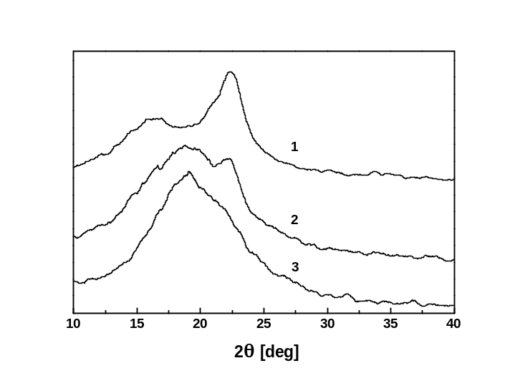  7.6  Fig.5 WAXD patterns of (1) unmodified fir sawdust and (2, 3) benzylated fir sawdust with different weight gains (curve 2: 47%, curve 3: 98%). |  | 1.3 | 1.1
*Weight gain=75%

Fig.5 gives the WAXD patterns of untreated and treated fir sawdust. It is seen that the peak at 2θ=22.2° of the as-received sawdust (curve 1), which is derived from the reflection of (002) plane of cellulose I lattice, diminishes after benzylation (curve 2) and forms broader scattering when the extent of benzylation is significantly increased (curve 3). As the diffraction peak profiles shown in curves 2 and 3 resemble those of ball-milled cellulose which had been decrystallized [7], it can be concluded that the above-stated variation in (002) reflection is a result of decrystallization. Such a decrystallization process helps to improve thermoplasticity of cellulose by breaking hydrogen bonds between cellulose molecules. It is believed that the large benzyl groups introduced onto cellulose bring in more free volumes and account for the change in the supramolecular structure. It is worth noting that an increased molecular mobility of cellulose is hard to result in an increased flowability of fir sawdust if the network of lignin keeps intact. Therefore, partial removal and damage of lignin structure as reflected by the absence of the carbonyl band at 1760cm⁻¹ and aromatic ether band at 1275cm⁻¹ (Fig.3) is necessary to get rid of the fetter, which further improves the extent of substitution of cellulose.

2. Mechanical properties
Prior to the discussion of sisal laminates, mechanical properties of the matrix, benzylated fir sawdust, should be known at first. As shown in Tab.2, the molded sheet of modified fir sawdust with a weight gain of 72.8% has the highest performance except for the flexural modulus. Similar to the case of original wood material, crystallinity and molecular weight of cellulose determine the mechanical properties of its plasticized version. For highly substituted wood, more crystalline regions of cellulose are destroyed, while a higher reaction temperature or longer reaction time which is required to increase substitution degree would result in severer degradation than the slightly substituted one. These contradictory effects are responsible for the reduced mechanical properties coupled with increased thermoplasticity (cf. Tab.2 and Fig.4). On the other hand, if the degree of substitution is so low that the modified fir sawdust can not be sufficiently melted, a sheet with lower mechanical properties but higher crystallinity retention would be yielded. Evidently, the benzylated fir sawdust with a weight gain of 72.6% seems to be well balanced. As a result, the benzylated products with weight gains of 70%-80% were selected as the matrix material for making sisal laminates in this work. Compared with cyanoethylated pine [5, 8], the benzylated fir sawdust has much higher impact toughness but lower static strength and modulus. The difference should be attributed to the modification techniques rather than wood species.

Tab.2 Mechanical properties of thermoformed sheets of benzylated fir sawdust
Weight Gain  (%) | Tensile Strength (MPa) | Young’s Modulus (GPa) | Flexural Strength (MPa) | Flexural Modulus (GPa) | Impact Strength (kJ/m²)
37.0 | 12.5 | 1.92 | 33.6 | 2.20 | 3.9
54.5 | 13.8 | 1.98 | 34.3 | 2.18 | 4.4
65.2 | 15.2 | 2.21 | 34.9 | 2.33 | 4.7
72.8 | 17.5 | 2.39 | 36.8 | 2.47 | 5.6
81.2 | 16.3 | 2.30 | 35.5 | 2.51 | 5.1
96.7 | 15.1 | 2.24 | 34.5 | 2.55 | 4.5
105.3 | 12.7 | 2.12 | 33.9 | 2.50 | 3.7

Fractured surface of molded benzylated fir sawdust is shown in Fig.6 and characterized as a rather rough topography, manifesting a ductile failure mode. Compared with the untreated one (Fig.2(a)), the texture of wood cells disappear due to the thermoforming process.

Tensile and flexural properties of unidirectional sisal reinforced benzylated fir sawdust composites are shown in Figs.7 and 8 as a function of sisal volume fraction, V_{f}. It is seen that moduli increase with sisal content in an approximately linear way, while the strengths reach a maximum at V_{f}=30vol%. Although the latter phenomenon can be attributed to the competition between the effects of reinforcement and micro-crack initiation as a result of
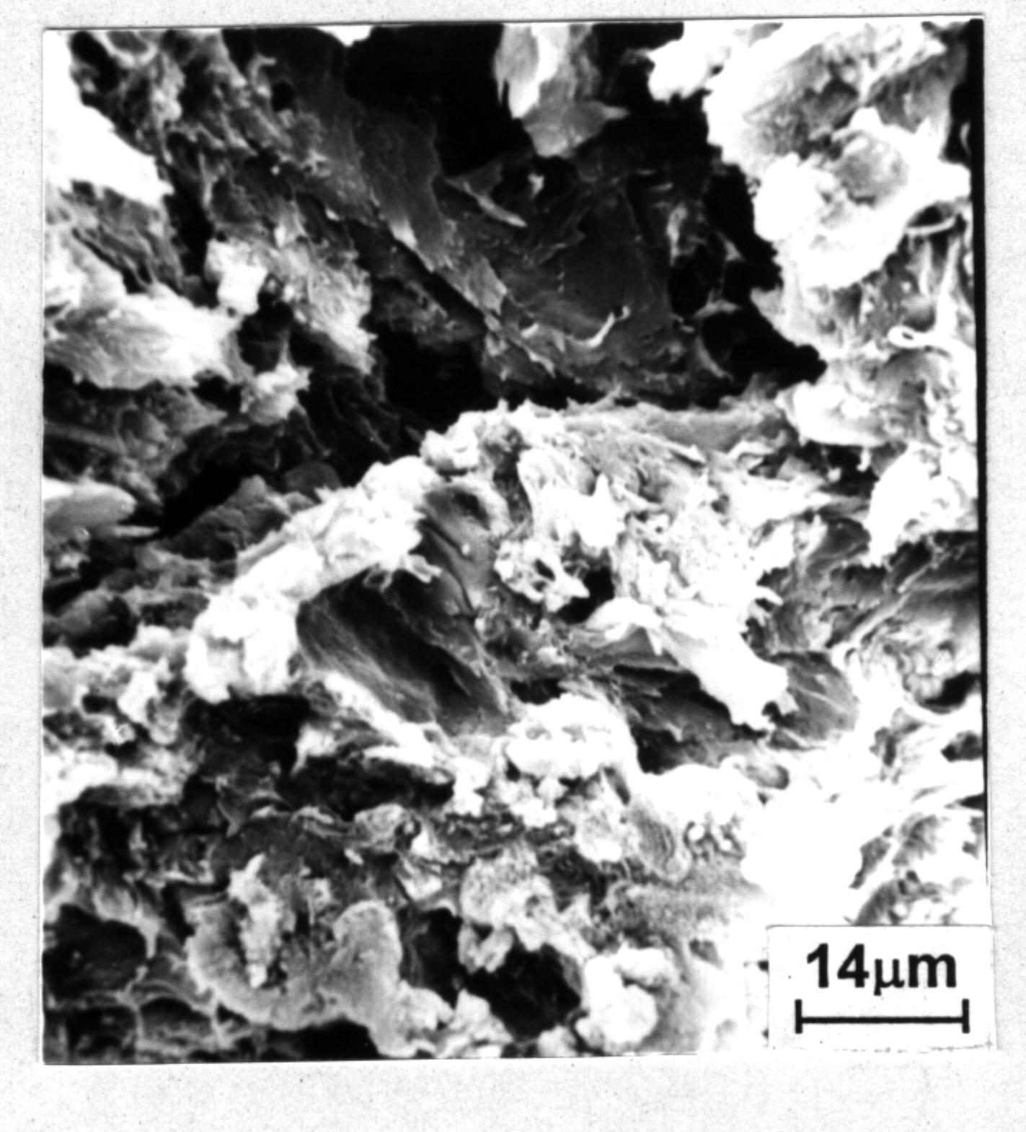
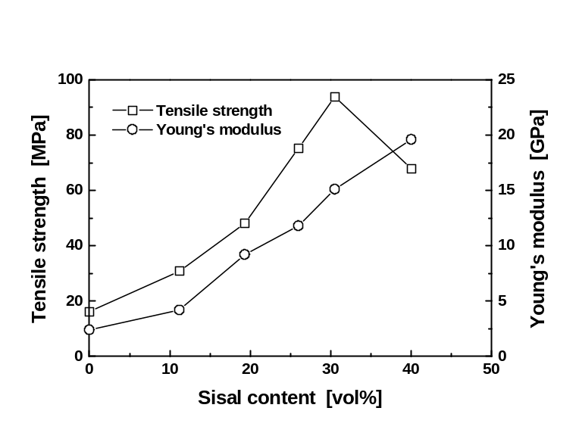
Fig.6 SEM micrograph of fractured surface of molded benzylated fir sawdust due to tension (weight gain=75%)
Fig.7 Tensile properties of unidirectional sisal/benzylated fir sawdust laminates as a function of sisal content

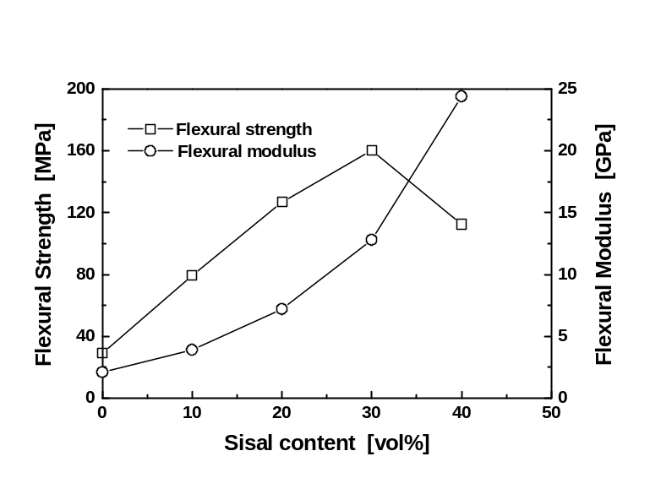
Fig.8 Flexural properties of unidirectional sisal/benzylated fir sawdust laminates as a function of sisal content

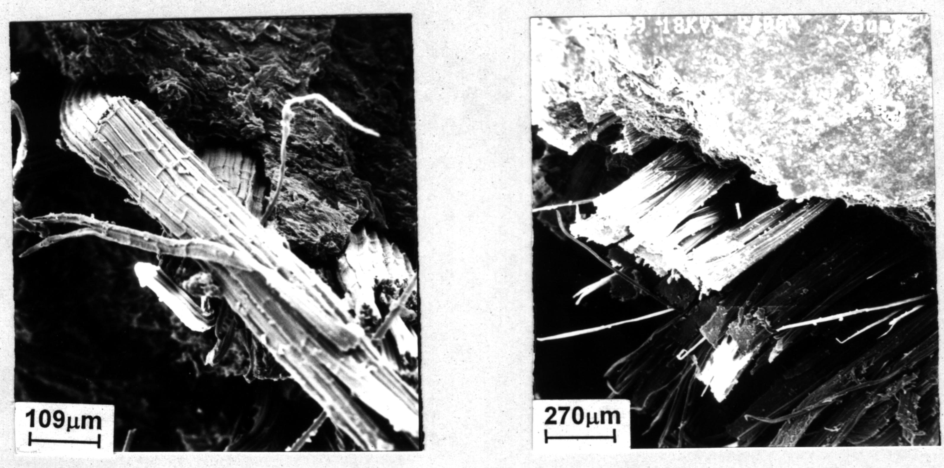
fiber incorporation, this drop in strengths appears too early. This is different from the results of thermosetting polymer based plant fiber composites. For example, a linear relationship between tensile strength and fiber loading were found up to V_{f}=60vol% in unidirectional jute/unsaturated polyester and sisal/epoxy systems [2, 9]. Obviously, wetting and absorption problems at the fiber/matrix interface should be responsible for this behavior. In the case of thermosetting resins, the low molecular weight monomers before curing facilitates impregnation of the reinforcing fiber bundles to form intimate adhesion. For benzylated fir sawdust which has a quite high melt viscosity, it is somewhat difficult to impregnate sisal fibers under the current processing conditions, as convinced by the cohesive debonding at the interface (Fig.9). That is, the kinetic barrier leads to insufficient interfacial bonding in spite of the fact the fiber reinforcement and matrix are thermodynamically compatible. Consequently, the strengthening effect of sisal fibers can not brought into full play especially at a fiber content higher than 30vol%.
Fig.9 SEM micrographs of fractured surface of unidirectional sisal/benzylated fir sawdust laminates due to tension (V_{f}=30vol%)

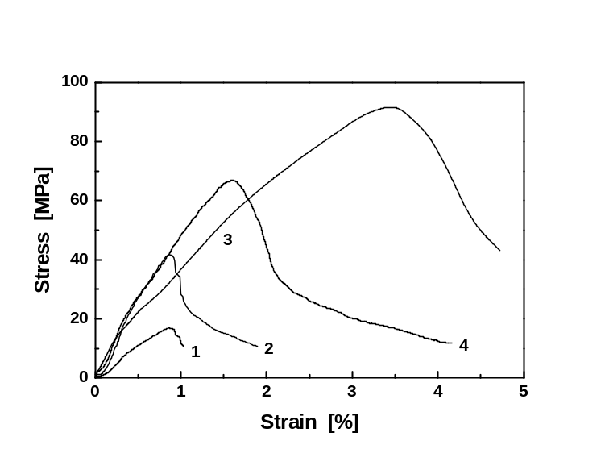

Fig.10 Typical stress-strain curves obtained from tensile tests of (1) benzylated fir sawdust, (2) sisal/benzylated fir sawdust laminates (V_{f}=19.7vol%), (3) sisal/benzylated fir sawdust laminates (V_{f}=31vol%) and (4) sisal/benzylated fir sawdust laminates (V_{f}=40.4vol%)

It is interesting to examine the failure behavior reflected by the tensile stress-strain plots in Fig.10. Unlike unidirectional sisal/epoxy laminates which are characterized by brittle failure [9], the current composites show long tails after the predominant damage. Such a post-failure crack propagation resistance improves the safety of use and must be related to the interfacial failure characteristics. That is, the localized shear deformation of the ductile matrix induced by the reinforcing fiber accounts for the phenomenon. It is thus expected that an increased interfacial interaction in the present laminates would result in a higher elongation to break.
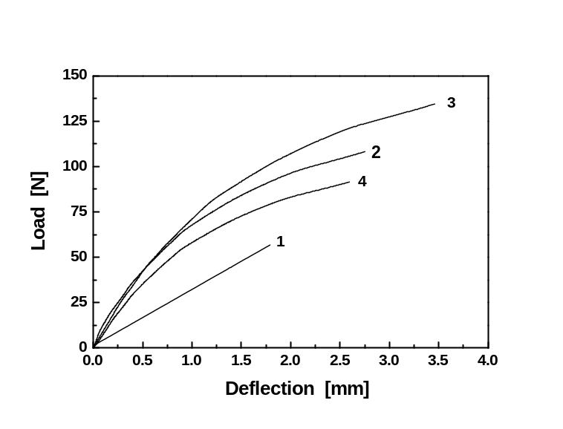
Fig.11 Typical load-deflection curves in three-point bending tests of (1) benzylated fir sawdust, (2) sisal/benzylated fir sawdust laminates (V_{f}=19.7vol%), (3) sisal/benzylated fir sawdust laminates (V_{f}=31vol%) and (4) sisal/benzylated fir sawdust laminates (V_{f}=40.4vol%)

Fig.11 shows the load-deflection curves of the laminates. It is well known that the upper and lower surfaces of the specimen under three-point bending load are subjected to bending stress (compression and tension) and the axisymmetric plane is subjected to shear stress. There are two failure modes in the materials: flexural and shear failures, which are revealed by the force-deflection curves obtained by three-point bending [10]. That is, when the specimen fails so abruptly that the curve is practically linear, it can be attributed to a flexural failure mode. When the specimen fails in the way that the slope of the force-deflection curve decreases gradually to zero, shear failure takes place. The appearance of a curve shown between these two forms can be considered as a result of a mixed failure mode. According to this criterion, it is clear that failure of plasticized fir sawdust is flexural failure, while failure of the composites are mixed failure mode in association with a great contribution of shear deformation (Fig.11). In this case, flexural properties of these unidirectional laminates are factually controlled by the resistance to interlaminar failure.

CONCLUSIONS
- By means of benzylation, fir sawdust can be converted into a thermoplastic material. In comparison with cyanoethylated products, benzylated wood flour has higher thermoplasticity and toughness.
- Melt viscosity and mechanical performance of benzylated fir sawdust is a function of the extent of benzylation, which provides posibilities for tailoring the structure-properties relationship. From technical point of view, the modified fir sawdust melt is thermally sensitive but not pressure sensitive.
- Unidirectional sisal reinforced plasticized fir sawdust laminates can be manufactured by similar techniques available for conventional thermoplastic composites and exhibit moderate modulus and strength. To improve the mechanical properties, the flow behavior of the matrix should be greatly improved to ensure sufficient impregnation and interfacial adhesion. Another possible solution might lie in the production of self-reinforced composites, i.e. surface of the reinforcing plant fibers is appropriately plasticized and then the fibers are bound together without additional matrix resin under the joint action of temperature and pressure. In this way, uncoiling of the spirally arranged microfibrils inside plant fibers, which consumes substantial energy, would occur and provide the composite with enhanced performance. A paper on this topic will be published in the near future.

Acknowledgment
The financial support by the National Natural Science Foundation of China (Grant: 59725307), the Key University Teachers Training Program of the Ministry of Education of China, the Team Project of the Natural Science Foundation of Guangdong and the Talents Training Program Foundation of the Higher Education Department of Guangdong Province are gratefully acknowledged.

References
- Klason, C., Kubat, J. and Gatenholm, P., “Wood fiber reinforced composites” in Viscoelasticity of Biomaterials, W. G. Glasser and H. Hatakeyama (ed.), American Chemical Society, Washington, 1992, 82-98.
- Bledzki, A. K. and Gassan, J., “Composites reinforced with cellulose based fiber”, Progr. Polym. Sci. 24, 1999, 221-274.
- Morita, M. and Sakata, I., “Chemical conversion of wood to thermoplastic materials”, J. Appl. Polym. Sci. 31, 1986, 832-840.
- Hon, D. N. S., “Chemical modification of lignocellulosic materials: old chemistry, new approaches”, Polym. News 17, 1992, 102-107.
- Lu, X., Zhang, M. Q., Rong, M. Z., Shi, G., Yang, G. C. and Zeng, H. M., “Natural vegetable fiber/plasticized natural vegetable fiber - a candidate for low cost and fully biodegradable composite”, Adv. Compos. Lett. 8, 1999, 231-236.
- Hon, D. N. S. and Josefina, M. S. L., “Thermoplastization of wood. I. Benzylation of wood”, J. Polym. Sci., Part A: Polym. Chem. 27, 1989, 2457-2482.
- Heritage, K. J., Mann, J. and Roldan-Gonzalez, L., “Crystallinity and the structure of celluloses”, J. Polym. Sci., Part A: Polym. Chem. 1, 1963, 671-695.
- Zhang, M. Q., Rong, M. Z., Lu, X., Shi, G., Zeng, H. M. and Yang, G. C., ‘Manufacturing of natural composites’, Chinese Patent (CN1242396A), 2000.
- Rong, M. Z., Zhang, M. Q., Liu, Y., Yang, G. C., Zeng, H. M., ‘Effect of Fiber treatment on the mechanical properties of unidirectional sisal reinforced epoxy composites’, Composites Science and Technology (submitted).
- Zhang, M., Zeng, H., Zhang, L., Lin, G. and Li, R. K. Y., “Fracture characteristics of discontinuous carbon fibre-reinforced PPS and PES-C composites”, Polym. Polym. Compos. 1, 1993, 357-365.

